Justin Marucci

Assignment 5.2

1. Function: NOW()

Explanation:  
The NOW() function returns the current date and time in the format YYYY-MM-DD HH:MM:SS. It is useful when you need to timestamp entries such as user logins, transaction times, or record creation dates.

Example Query with Alias:

SELECT NOW() AS 'Current Timestamp';

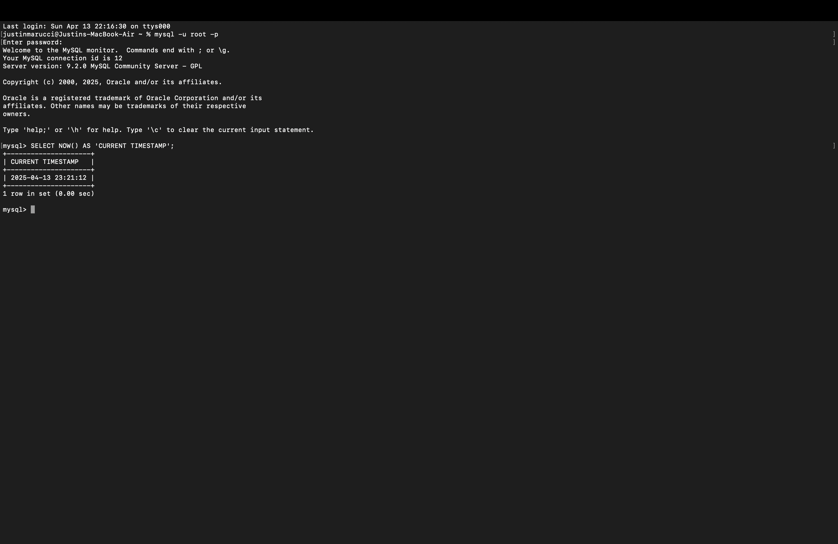

1. Function: LENGTH()

Explanation:  
The LENGTH() function returns the length of a string in bytes. It's helpful for data Validation or analyzing input lengths

Example Query with Alias:

SELECT LENGTH('OpenAI') AS 'String Length';

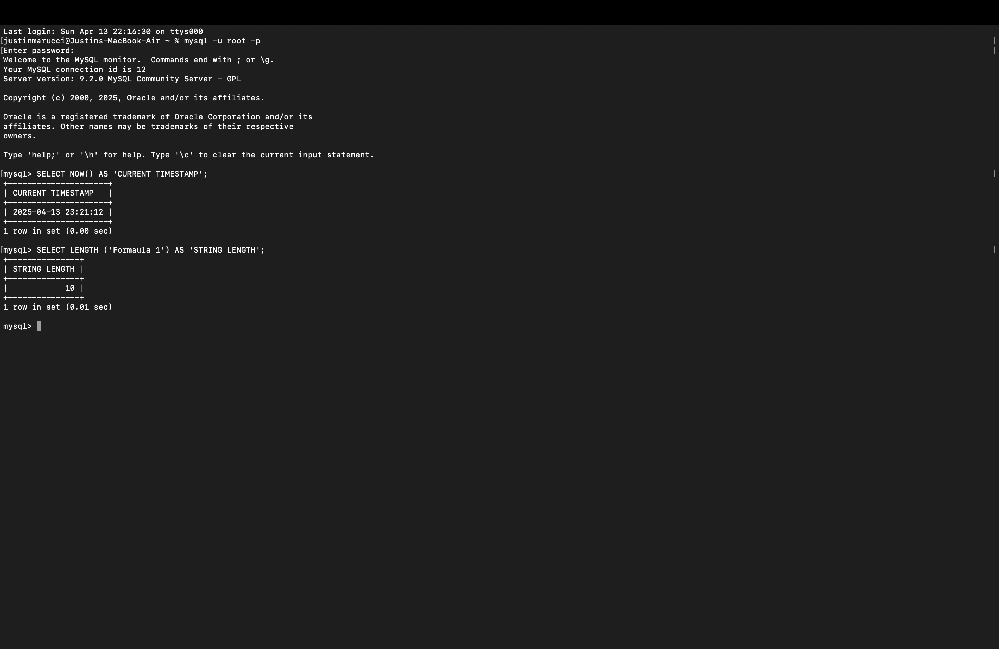

#### **3. Function: UPPER()**

**Explanation:**  
The UPPER() function converts a string to all uppercase letters. It's useful when standardizing text input, for instance, storing all country names in uppercase for consistency.

**Example Query with Alias:**

SELECT UPPER('hello world') AS 'Uppercase Text';

